News Release:
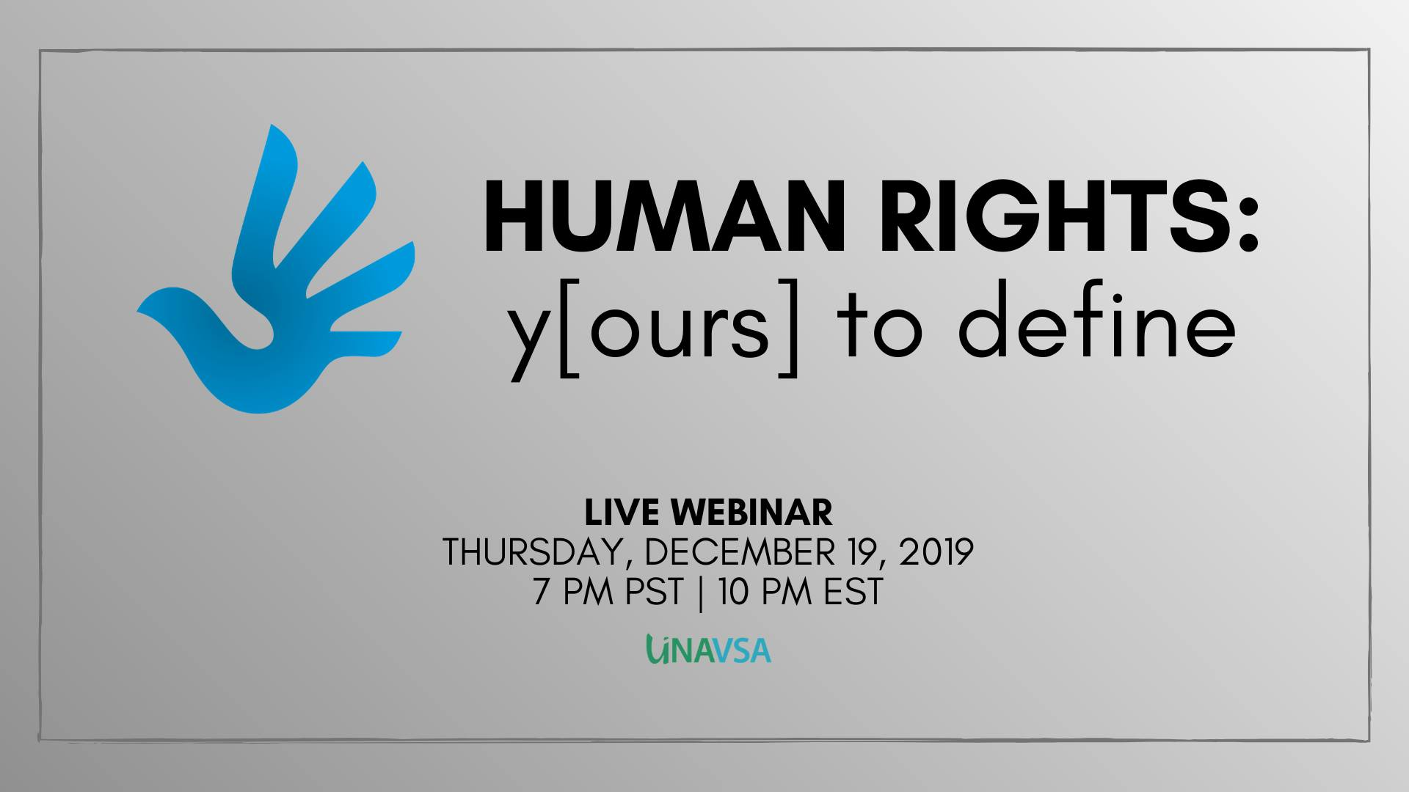

MOL's President to present at UNAVSA's Human Right's webinar on child right in Vietnam
December 19th, 2019

Theresa Tran, MOL's president, was invited by Union of North American Vietnamese Student Associations (UNAVSA) to present at its first time ever webinar on December 19th, 2019.

In light of International Human Rights Day on Tuesday, December 10th, UNVASA's "Human Rights: y[ours] to define" webinar is designed specifically to help everyone explore the importance of human rights, and ultimately, what it means to have these rights and freedoms. Messengers of Love is honored to be a guest speaker joining UNAVSA to explore human rights, presenting on the topic of “Child’s Right in Vietnam” and the projects we have developed to bring aid to Vietnam.

There will be discussion on the current human rights issues occurring within Vietnam and how non-profit organizations are helping combat this, and ensuring Vietnamese citizens the same quality of rights and freedoms that we all deserve. Also there will be discussion on steps WE can take to help tackle human rights issues and learn how to share it with our family and friends so we can all make this world a better place together.
Because together, we can define what it means to be human. Together, human rights are y[ours] to define.
Feel free to reach out to Civic Engagement at civic.engagement@unavsa.org or messengersoflove@gmail.com if you have any questions, comments, or concerns. We hope to see everyone there.

Theresa Tran

